
How to prepare your child for Nursery

- Talk to your child about what to expect in Nursery and look at the photographs of our staff, building and Nursery grounds.

- Recognise and talk through your child’s feelings and different emotions, this will help them to understand and communicate how they are feeling with staff.
- It is important for children to listen and follow instructions at nursery, these can be enhanced at home by playing games such as snap and giving simple instructions e.g. hang your coat up and wash your hands.
- Talk to your child without distractions from the TV, radio or tablet. Talk about shared experiences that you have enjoyed such as visits, shopping trips, or things you have seen.
- Develop self-help skills by encouraging your child to take off and put on their own jumper and coat. Support your child in doing up zips, buttons and poppers; we understand that these can be tricky so make it fun by dressing up toys in old clothes. Encourage your child to take their shoes and socks on and off. Don’t wait till the first day - give them time to practice.
- Support your child in getting to the toilet in time, wiping themselves, flushing the toilet and washing their hands. If your child is wearing nappies we will work with you and your child to support them during toilet training. Sometimes children are so involved in play that accidents do happen.
Please talk to your child about what to do if an accident happens, reassuring them and telling them to tell an adult.
- Encourage your child to blow their nose themselves, bin the tissue and washing their hands. If reinforced at home and school this will become the norm and your child will develop a healthy routine.
- If your child will be having a packed lunch at school, talk with your child about the food you will be putting in their lunch box. Help will be on hand to open packets and take off lids but practising doing this at home first will encourage your child to become more independent. Lunchtime in Nursery lasts for 30 minutes so if your child is a particularly slow eater (which is not uncommon), it would be helpful to begin encouraging a faster pace when eating. Of course, children can continue to eat beyond the lunchtime period if more time is needed!
- Your child will have a peg with their photo and name on for their coat, therefore it would be helpful for your child to begin to recognise their own name. To reinforce this you could put a name card on the fridge or play a treasure hunt game; finding name cards around the house.
- Establish a good sleep routine for your child.
- Arrange play dates with other parents and their children. Encourage sharing, socialising and turn taking.
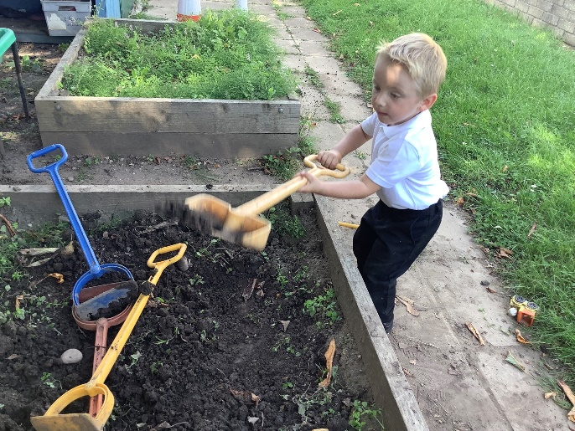

How you can support your child throughout the year
Personal, social and emotional development
One of the main aspects of your child’s time at nursery will be a focus on their personal, social and emotional development. They will be encouraged to develop positive relationships, to play with a variety of friends and to understand the feelings of others. There will be opportunities to build confidence and self-awareness, and also to manage their feelings and behaviour.
You can help at home by:
- Playing games together and encouraging turn-taking. Ensure that your child does not win every time! Children need to learn that they cannot win every time and also learn to handle their emotions in an appropriate way when this happens.
- Talking about feelings/emotions with your child. Discuss your own feelings, those of family members, those of characters in stories and try to help your child understand their own feelings and emotions, as well as recognising the feelings of others.
- Talking about the effect of certain behaviour and how it may make other people feel.
- Promoting the sharing of toys with friends and siblings.
- Modelling and encouraging friendly behaviour and good manners
- Encouraging greater independence when carrying out tasks
- Communication and Language
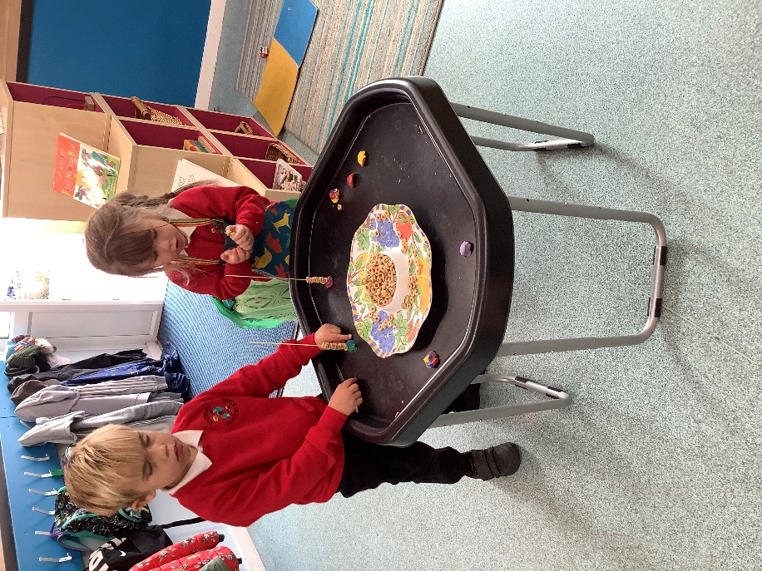
Communication is a key area of your child’s learning in nursery. We will spend lots of time sharing rhymes, songs, stories and playing games to develop the children’s speaking and listening skills. They will be encouraged to learn to listen carefully, to develop concentration, to respond to questions and instructions, to share ideas and experiences and to take part in conversations.
Talking and listening
It seems very obvious, but at this stage one of the best things you can do for your child’s learning is to spend time talking together. They are constantly learning new words and will be exploring ways to build sentences and put words together through trial and error. Try talking to your child without distractions from the TV, radio or tablet. Encourage eye contact and back-and-forth conversation. Get them talking about the toys they are playing with. Ask them for their opinion about things – what is their favourite piece of equipment to play on in the park and why? Talk about shared experiences that you have enjoyed such as visits, shopping trips, or things you have seen. Chat together about what you need to buy from the shop and encourage them to help you find items.

You can help at home by:
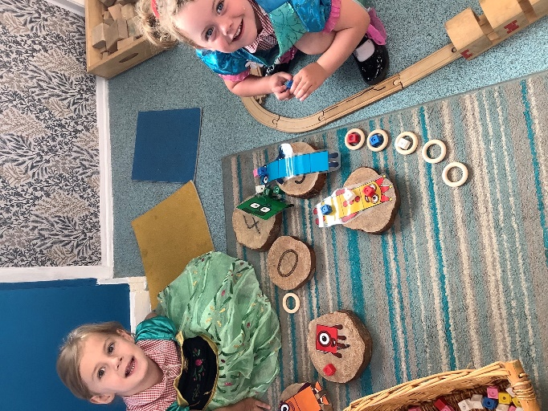
- Singing songs and rhymes together to develop vocabulary and an awareness of rhyme, rhythm and alliteration.
- Sharing lots of stories together and discussing the storyline and characters together.
- Giving your child little instructions to follow. You could give your child little responsibilities around the house and special jobs to do. For example; emptying the washing machine and talking about how the clothes are all wet and heavy before hanging them out to dry together. Laying the table for dinner; counting out the cutlery and plates. Making the beds together and even washing up! However tedious all these jobs are to us, your child will love joining in and being involved!
- Encouraging your child to talk to different people you know to develop their confidence and vocabulary.
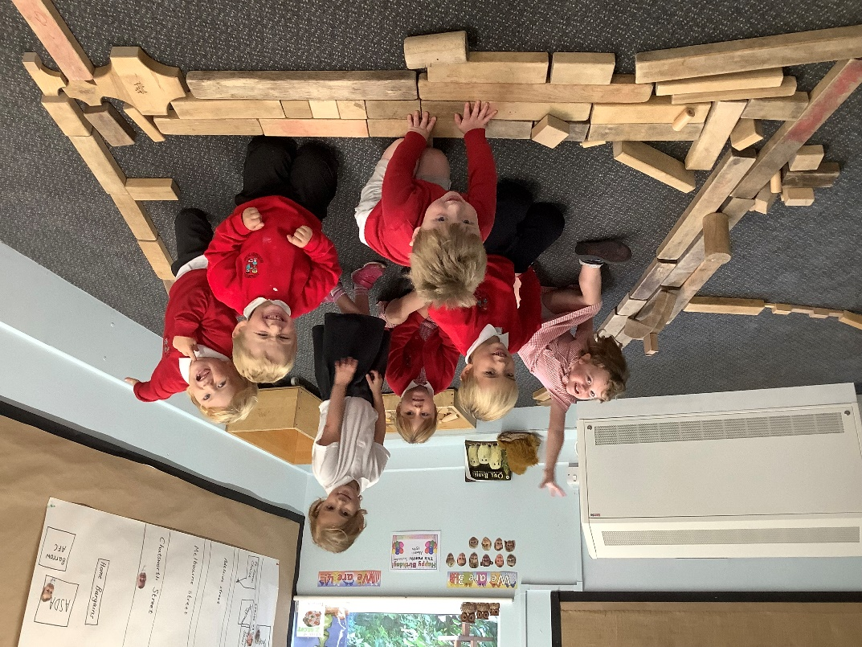

Physical development
Your child will be given lots of opportunities to move in different ways, for example, running, jumping, balancing and playing with balls. Another important aspect of physical development at this stage is learning to hold and use tools, such as scissors, and also to use pencils and pens to draw lines and shapes. Your child will also begin to understand how to look after themselves and be healthy.
You can help at home by:
- Taking your child to the park to practise climbing, balancing and other large movements.
- Throwing and catching with balls, beanbags, hoops, etc.
- Making obstacle courses together in the garden
- Hanging up washing or building dens using pegs
- Playing hopscotch
- Drawing out chalk lines outside for your child to walk, hop, jump along
- Dancing to different styles of music
- Riding a bike or scooter
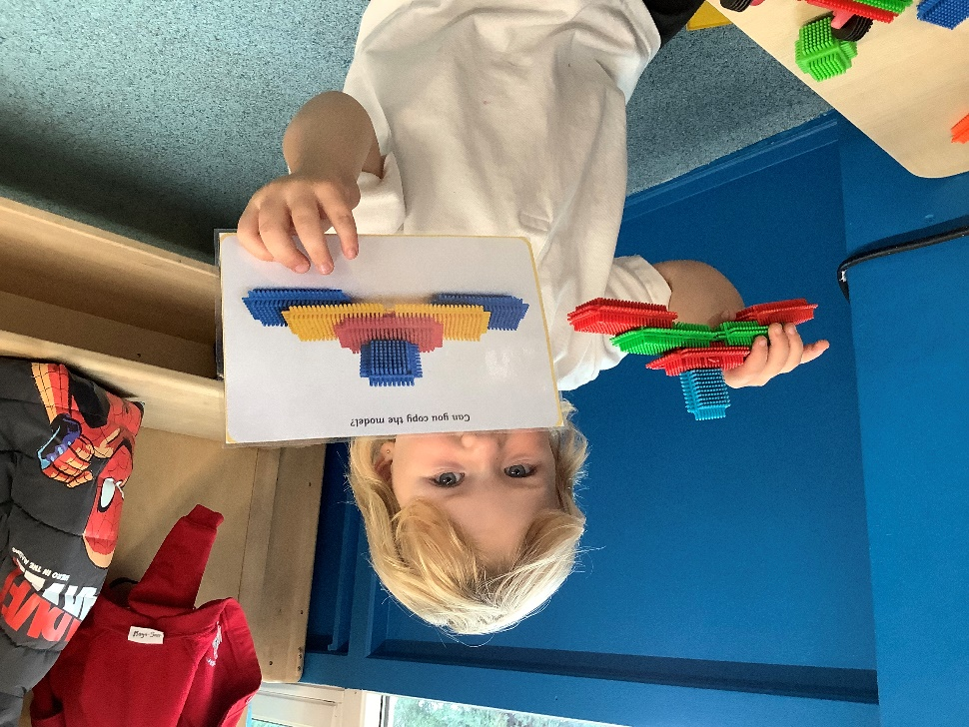
- Encouraging your child to help you with chores, e.g. washing windows, cleaning the car, sweeping up leaves.
- Threading
- Playing with play dough
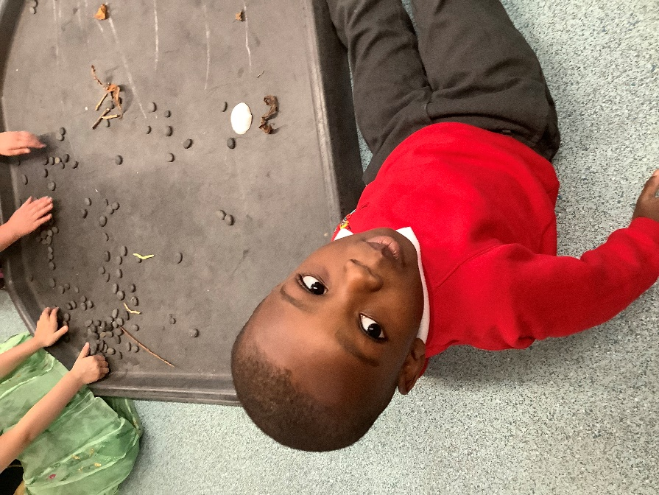
- Making marks and patterns using a pencil, paint or chalk
- Playing with spray bottles filled with water outside
- Making marks outside by drawing in mud/sand with sticks, chalking on the ground or wall, using large paintbrushes/paint rollers with water
- Practising cutting skills
- Doing jigsaws
- Encouraging your child to get themselves dressed and undressed independently - using buttons, zip-ping up their own coat
- Teaching your child about being hygienic e.g. washing their hands after going to the toilet, before touching food
- Talking about keeping safe whilst out and about e.g. crossing the road
- Using a knife and fork when eating
- Talking to your child about healthy eating
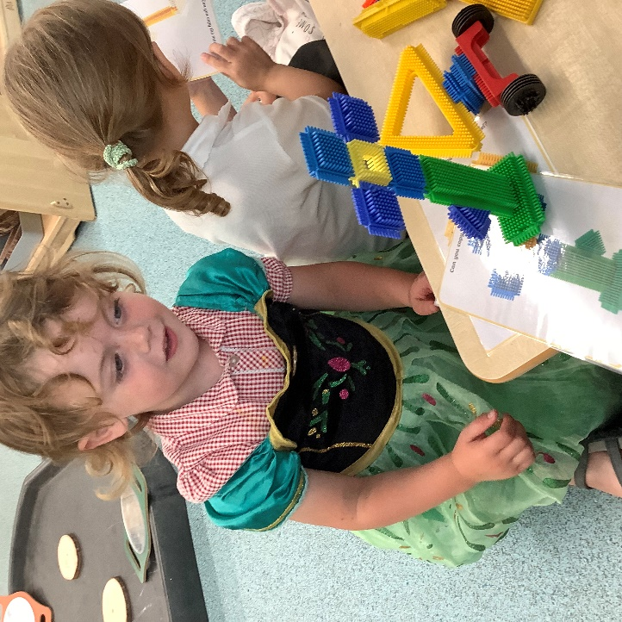

Literacy
The ‘Communication’ section above outlines some activities to develop speaking and listening skills. In addition to sharing lots of stories, your child will be encouraged to handle and look at books independently and to begin to learn about how stories are structured.
Phase 1 of our phonics programme will be taught, using the Jolly Phonics songs and pictures to support this later on in the year. You will be provided with more information regarding our phonics teaching during the Autumn term.
Your child will also be taught to recognise and write their own name with correct letter formations.
Read, read, read!
Time spent reading together brings so many benefits to your child – and you! Through reading, your child will hear lots of words that they might not be as likely to come across in everyday conversation. They will also develop their listening skills and develop their understanding of how stories work. Rhythm and rhyme are so important for early language development and, luckily, there are masses of wonderful books available. Encourage your child to talk about the pictures, or to make predictions about what will happen next.
Find out more information on the Oxford Owl Website:
https://home.oxfordowl.co.uk/reading/early-reading-skills-age-3-4/
https://home.oxfordowl.co.uk/blog/using-storytelling-to-develop-reading-and-writing-skills/
You can also help at home by:
- Sharing bedtime stories.
- Visiting the library regularly. Find books that relate to things you have been talking about with your child as well as allowing your child to choose books that interest them. Try to choose a mix of fiction and non-fiction.
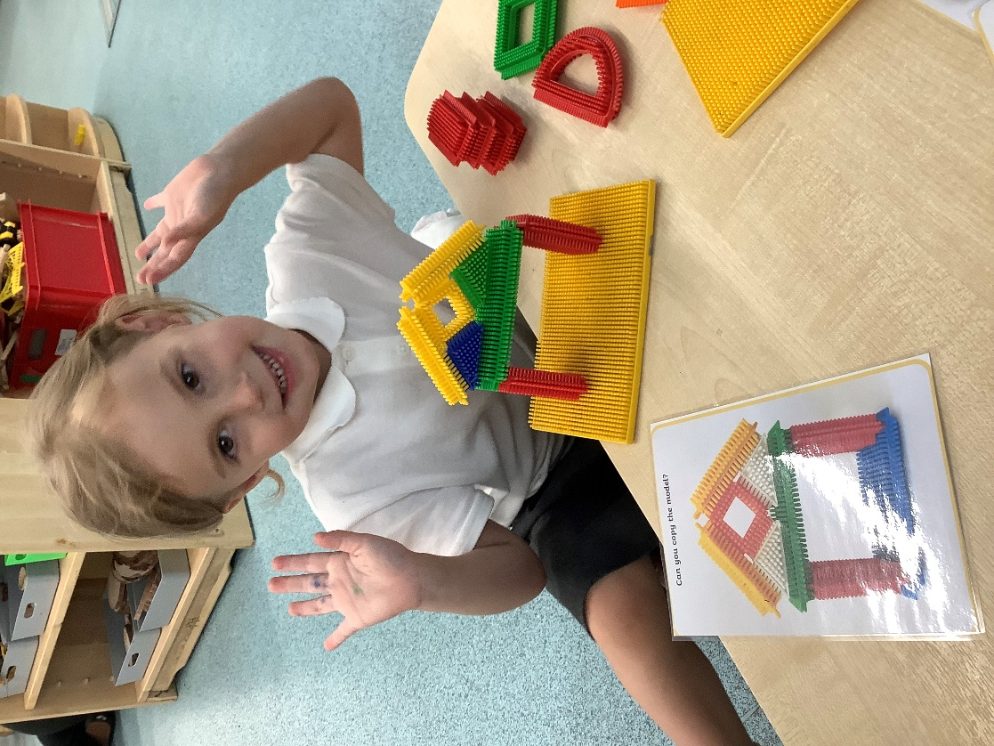
- When out and about, draw your child’s attention to signs and print in the environment.
- Letting your child hear you reading out loud for a purpose, e.g. a menu, cooking instructions,
a shopping list, etc.
- Creating a reading den where you can spend special time together sharing a story.
- Playing ‘I Spy’ in the traditional way but also try sounding out the whole word for your child, e.g. “I spy a c-a-t”. This will help with oral blending, a key skill needed for early reading.
- Referring to letters by their sound and not their name (more advice will be given at our phonics meeting in the Autumn term)
- When practising spelling your child’s name please encourage them to use lower case letters (except for the starting letter) along with correct letter formations.
Mathematics
Your child will be given many opportunities to explore numbers and shapes in their play. For example, they will be encouraged to count objects they are playing with and to compare two groups of objects. They will also begin to represent numbers using their fingers, marks on paper or pictures. They will mostly be using numbers to 10 and will begin to recognise the total of a small quantity of objects without the need to count them, e.g. the dots on a dice.
Children will explore shape and pattern as well as the beginnings of weight, measure and capacity.
You can help at home by:
- Singing lots of counting rhymes- 10 in the bed, 5 currant buns, 5 little ducks, 5 cheeky monkeys, 10 green bottles, etc.
- Counting aloud both forwards and backwards all the time! Give your child 10/20 seconds to complete a task (counting out loud), count the number of stairs every time you climb them, point and count out numbers of toys, etc.
- Pointing out the numbers you see when you are out and about and encouraging your child to do the same, e.g. look for bus numbers, prices and house numbers.
- Having a number hunt when walking to school or driving in the car, e.g. the first person to spot a number 8 is the winner!
- When shopping, ask your child to select the number of apples or bananas you need.
- Baking- use cupfuls of ingredients or practise weighing out ingredients.
- Playing shop- counting out objects in your basket and talking about prices/money
- Playing Snakes and Ladders or other games where you roll a dice and move a counter.
- Playing number themed games (Orchard Games have a huge range!)
- Play online number games- www.topmarks.co.uk have some brilliant games for Nursery children
- Playing skittles
- Counting actions as well as objects, e.g. Keep a score of how many goals you score playing football or count how many times you can throw a ball and catch it without dropping it, etc.
- Timing how long it takes to complete your obstacle course or other activity.
Understanding the world
Your child will learn about the world around them and will be able to use simple technology and equipment. They will learn about other people’s cultures and traditions and recognise some of the differences and similarities between themselves and their friends.
You can help at home by:
- Going on outings (farm, zoo, aquariums, beaches, the countryside, parks, cinema, theatre, etc) and talking about the things you see and experience. Take lots of photos so that you can recall the experience at a later date, talking about what you did, who went, what you found out and what they liked best about it.
- Talking about what you see, hear, smell, touch, taste.
- Going on nature walks and collecting natural objects
- Going on a bug hunt
- Encouraging short periods of time on the computer/ IPads
- Encouraging the use of a telephone (under supervision)
- Letting your child select a channel on the TV, using the remote control
- Playing with remote control or programmable toys
- Bringing in photographs from holidays or trips to share with the class
- Baking together and talking about the changes in the ingredients
- Talking about different environments and countries
- Talking about the weather and changes in seasons
- Discussing and finding out about different animals, insects, dinosaurs, birds, people etc
- Involving your child when out shopping—encourage them to find items
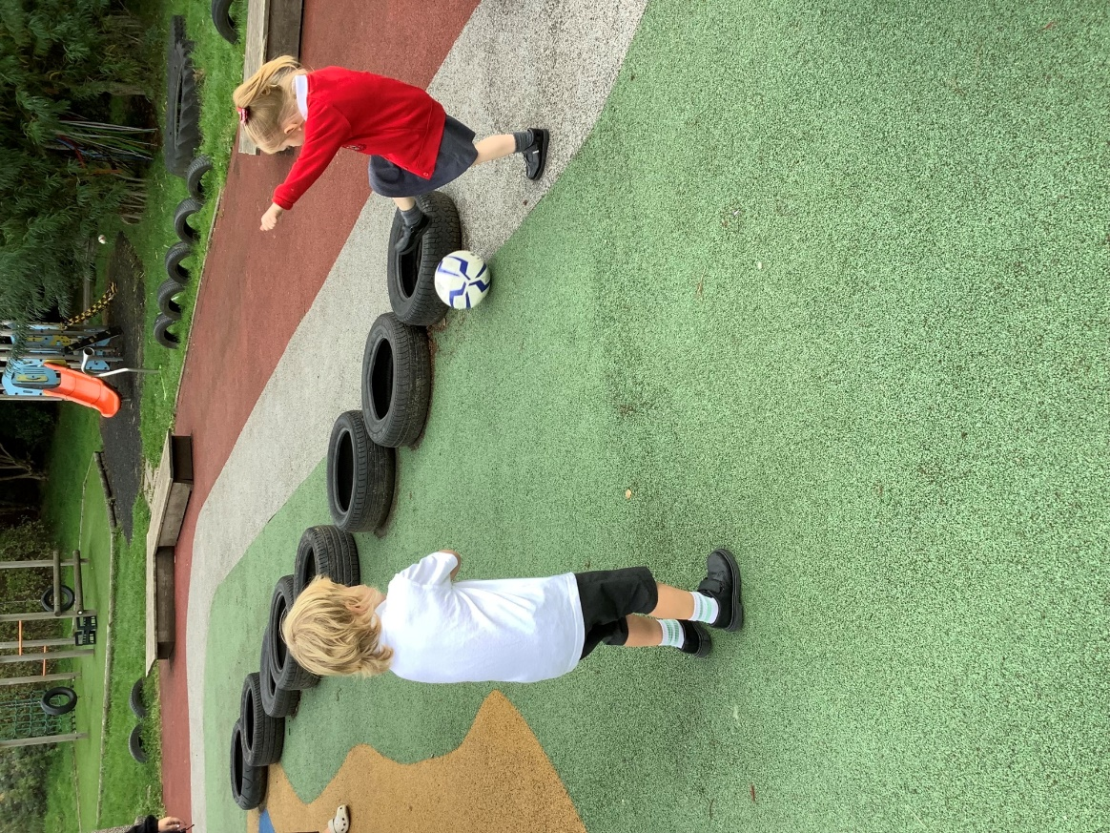
- Encouraging your child to ask questions about the world around them and questioning their knowledge and understanding too
- Talking about your own experiences past and present.
- Talking about different cultures and about the similarities and differences between themselves and others.

Expressive arts
Imagination and creativity are explored and developed in the area of expressive arts. Your child will explore different media and materials and be encouraged to use their imagination in a range of different experiences including art, design, role play and music.
You can help at home by:
- Encouraging your child to paint/ draw by providing them with different materials indoors and outdoors e.g. paper, pencils, chalk, paints, old sheets, wall paper, different sized brushes
- Playing music to your child
- Dancing to different styles of music
- Singing all different types of songs with your child
- Making music together with everyday objects, e.g. a wooden spoon and a pan or rice in a bottle.
- Making dens outside
- Making models with Lego, Duplo, wooden blocks, etc.
- Experimenting with different ways of making things such as using card, paper, cardboard—which works best
- Junk-modelling
- Exploring different ways of attaching things together
- Letting your child design what they are going to make
- Letting your child mix their own paints
- Using play-dough
- Letting them help you with painting
- Carrying out role play together
- Playing together with little figures/toys and allowing your child to develop the narrative
- Modelling good story language for your child during play
- Using puppets/toys to act out fairy tales and traditional stories such as The Three Little Pigs

Useful Websites
For lots of advice and ideas about the Early Years Curriculum
https://home.oxfordowl.co.uk/at-school/early-years/
https://www.foundationyears.org.uk/files/2014/08/EYFS_Parents_Guide-amended.pdf
https://www.birthto5matters.org.uk/
For the breakdown of the objectives that should be achieved within each age band across the curriculum, please see the document ‘Development Matters’ which can be found on:
https://assets.publishing.service.gov.uk/government/uploads/system/uploads/attachment_data/file/988004/Development_Matters.pdf

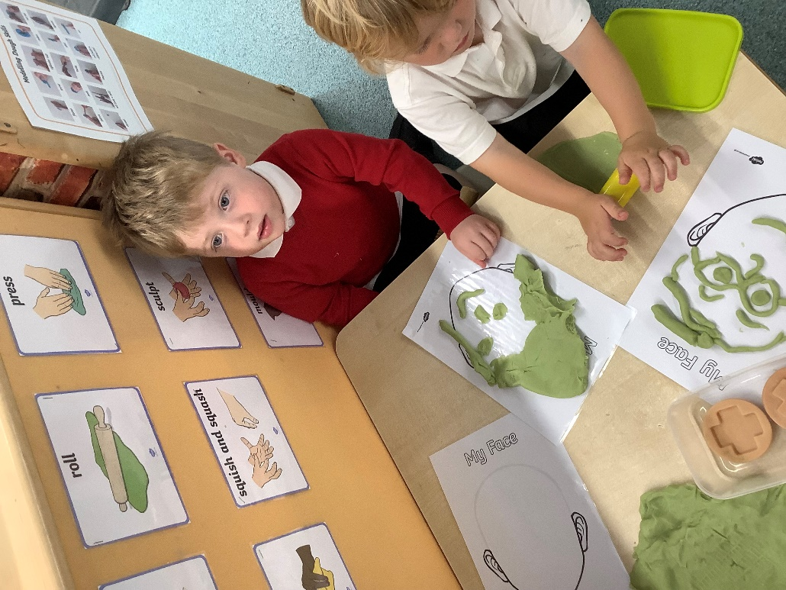
For online activities to try with your child:
www.topmarks.co.uk (select Early Years)
www.ictgames.co.uk
www.phonicsplay.co.uk (Phase 1)
www.phonicsbloom.com (Phase 1)
www.cbeebies.co.uk (Lots of educational programmes and games)

